IST 5520, Fall 2022, Chen

**Project Evaluation Form – Milestone 1: Proposal**

**Submission Due Sep 26, 11:59 PM**

**Instruction**

1. Discuss with your group members. Choose one of the datasets provided by the instructor for your group project.
2. Review at least three articles (peer-reviewed journal or conference articles) that are relevant to your selected dataset. Identify an interesting business problem that can be solved by using business analytics methods. Submit your project proposal.
3. The project proposal should include four sections:

* Introduction (background, business settings and scenarios etc.)
* Literature Review (a brief review of at least three peer-reviewed articles relevant to your project)
* Research Questions (what problems you intend to solve with the selected dataset)
* Data (specify data source; provide a data dictionary explaining the meaning of all columns; explain why the dataset is appropriate for addressing your research questions)

Read the evaluation criteria carefully on the next page for the detailed requirement.

1. Use Markdown in Jupyter notebook to write your project proposal. You need to use proper Markdown syntax to format your proposal. Do not use MS Word or other format.
2. Please create your group project repository on github and use it to manage all your project documents.
3. Please submit the following two documents to Canvas:

* The project proposal written in .ipynb file;
* The Evaluation form with full project team information (see the table on page 2).

**Project Repository**

Each group needs to use github to host their project and support collaborative work. To learn how to use github, refer to <https://guides.github.com/>. Please do not use gitlab (a different platform).

* Each group member needs to register a github ID (if you don’t have one) and work on the project repository.
* Please add the instructor (github ID: chenla-mst) as a collaborator for your group project. After you add the instructor into your group project, please copy the invitation link and send it to my email ([chenla@mst.edu](mailto:chenla@mst.edu)). See below for an example.

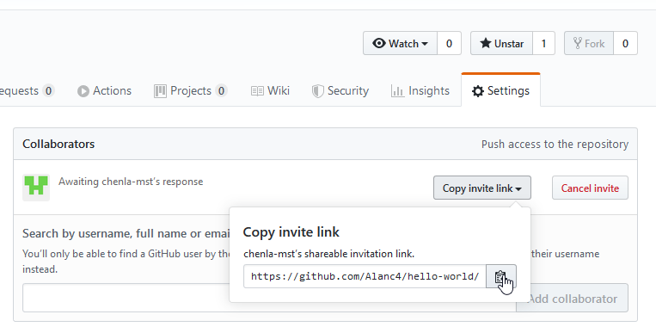

**Project Team Information (filled in by students)**

|  |  |  |
| --- | --- | --- |
| **Member name** | **Percent contribution** | **Activities completed by the member** |
| Sravani Chada | 25% | Research questions, GitHub Repo Creation, Project Proposal Writing |
| Prabhukanth Potlapalli | 25% | Literature Review, Project Proposal Writing |
| Lakshmi Pravallika Muttineni | 25% | Project Introduction and Scenarios, Project Proposal Writing |
| Sanjay Nimmagadda | 25% | Data Dictionary and Dataset Justification, Project Proposal Writing |
|  |  |  |
|  |  |  |

**Evaluation Summary – M1 (filled in by instructor)**

|  |  |  |  |
| --- | --- | --- | --- |
| **Criteria** | **Evaluation Points** | **Comments** | **Evaluation** |
| * Fully explain the business background and business problems you choose to analyze. * Introduce business scenarios or settings for your project. | 15 |  |  |
| * A brief but thorough review of at least three relevant peer-reviewed articles. | 20 |  |  |
| * Clearly define high-level project requirements and research questions. * Research questions should have significant implications for business. | 20 |  |  |
| * Specify data source(s) [and data collection method(s) if applicable]. * Clearly define the meaning of all columns in the dataset. * Explain why the dataset is appropriate for addressing the proposed research questions. | 20 |  |  |
| * Format your project proposal in a professional way. * Write your project proposal by using appropriate Markdown syntax. | 15 |  |  |
| * Create a github repository for your project. * All group members have joined the repository. * You have invited the instructor to join the repository. * Use the repository to manage all your project documents including meeting schedules, meeting minutes, and the proposal (the instructor should be invited to verify this). | 10 |  |  |
| **Total** | **100** |  |  |